Name:N.Akhilesh Kumar Dutt

USN:1BM19CS092

Section:3B

OOJ LAB OBSERVATION

Lab-Program-6:

Create a package CIE which has two classes- Student and Internals. The

class Personal has members like usn, name, sem. The class Internals has an

array that stores the internal marks scored in five courses of the current

semester of the student. Create another package SEE which has the class

External which is a derived class of Student. This class has an array that

stores the SEE marks scored in five courses of the current semester of the

student. Import the two packages in a file that declares the final marks of n

students in all five courses.

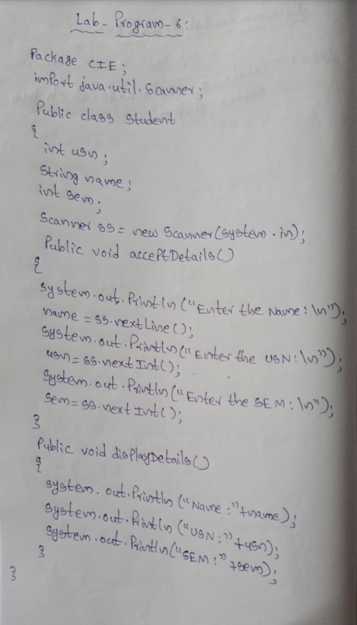

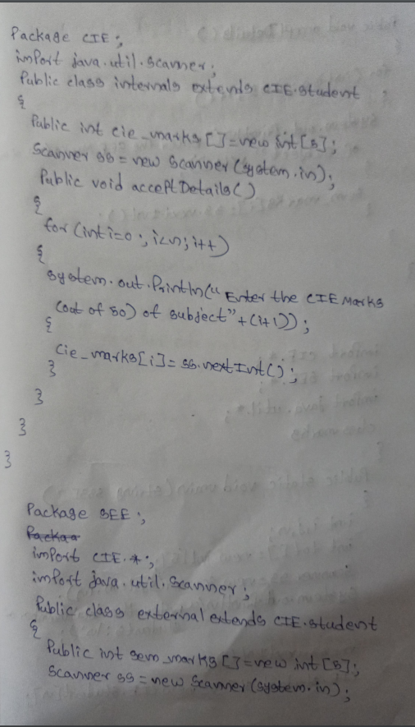

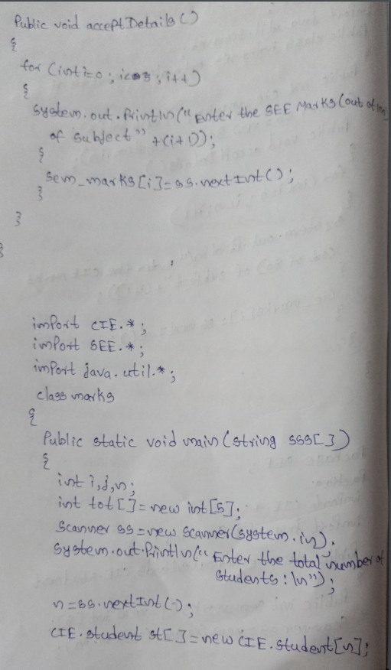

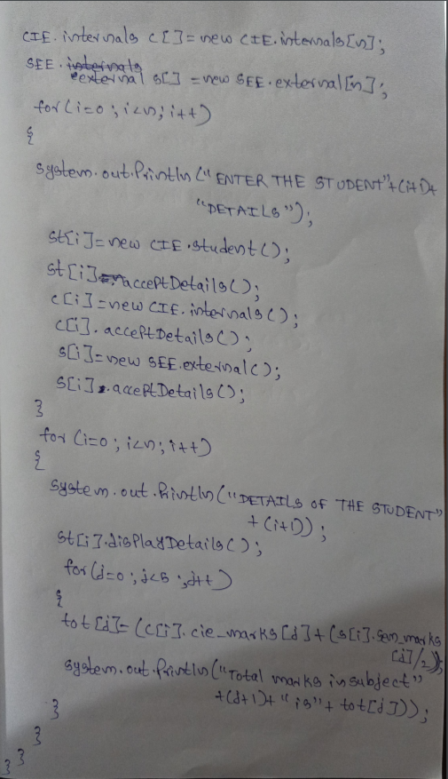

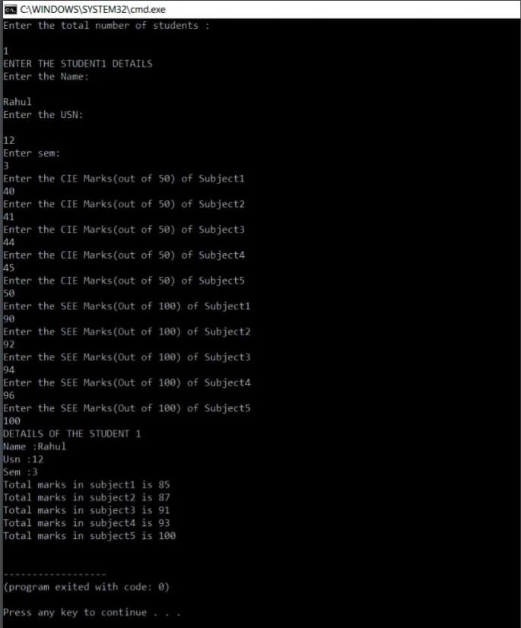

Lab-Program-7:

Write a program to demonstrate generics with multiple object parameters.

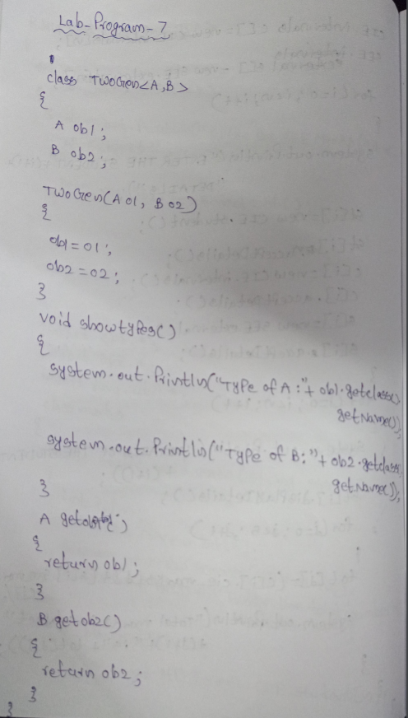

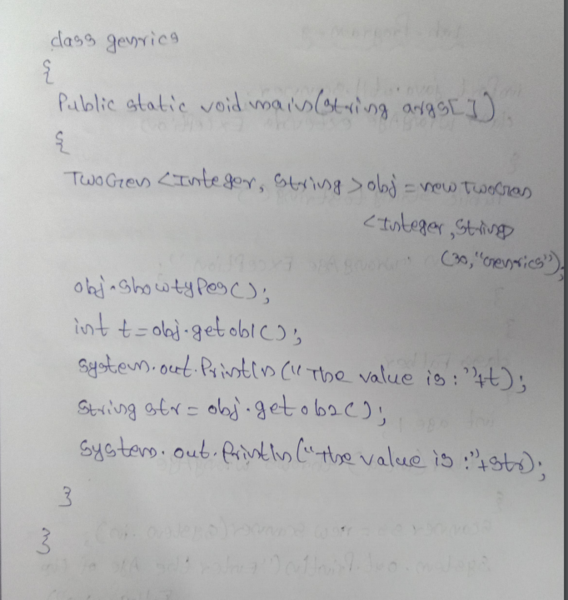

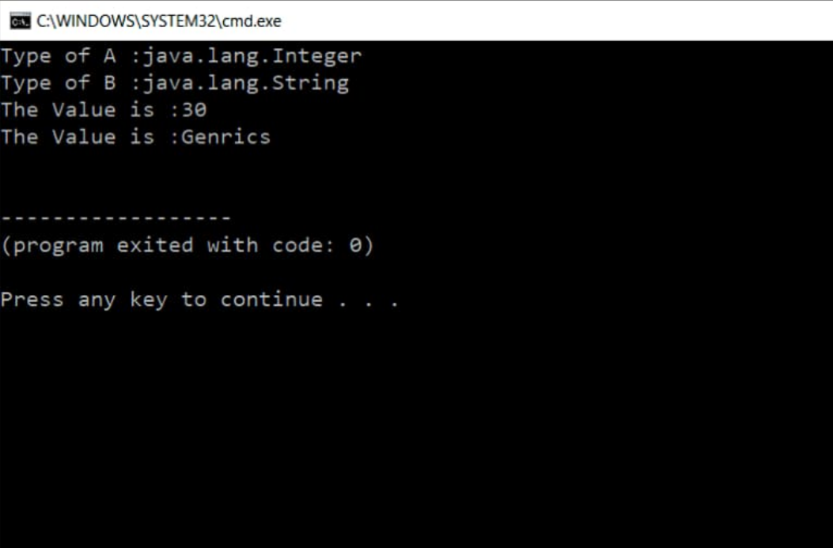

Lab-Program-8:

Write a program that demonstrates handling of exceptions in inheritance tree.Create a base

class called “Father” and derived class called “Son” which extends the base class.In Father

class,implement a constructor which takes the age and throws the exception Wrong Age()

when the input age<0.In Son class,implement a constructor that cases both father and son’s

age and throws an exception if son’s age is >=father’s age.

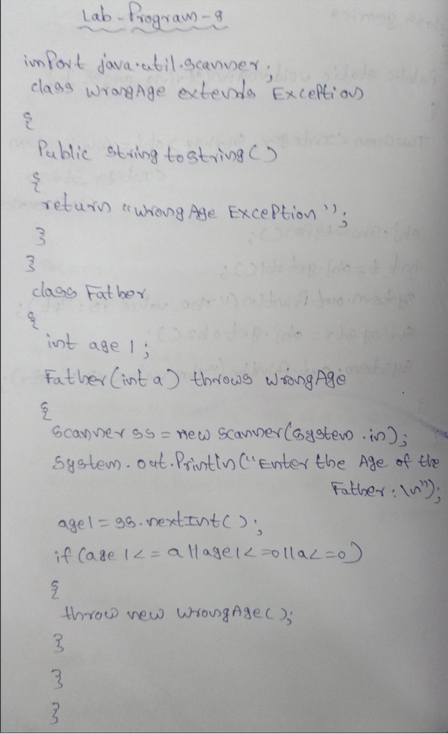

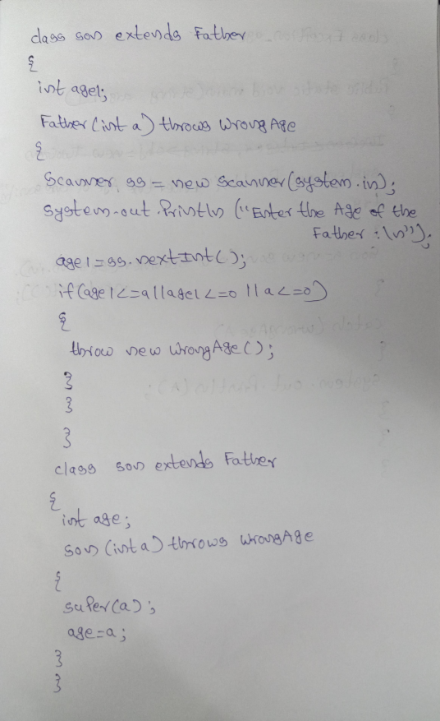

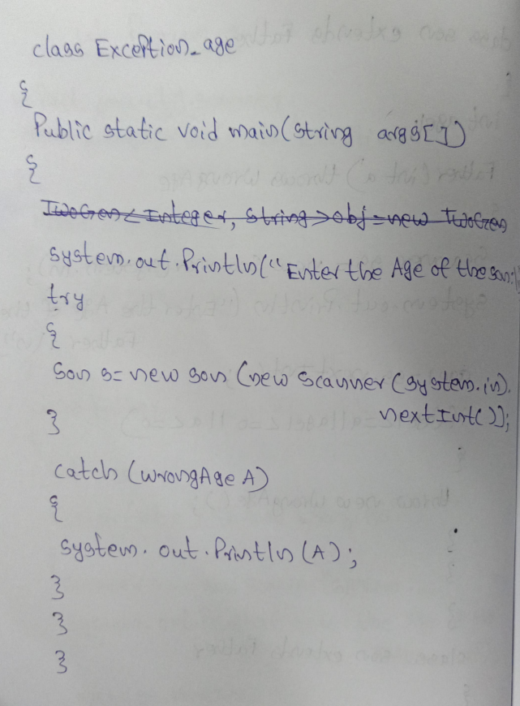

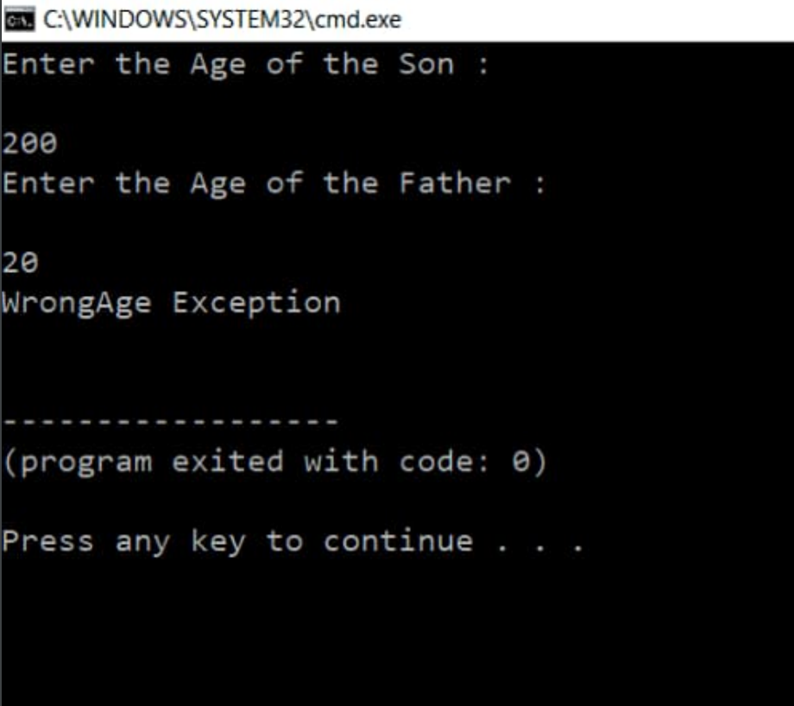

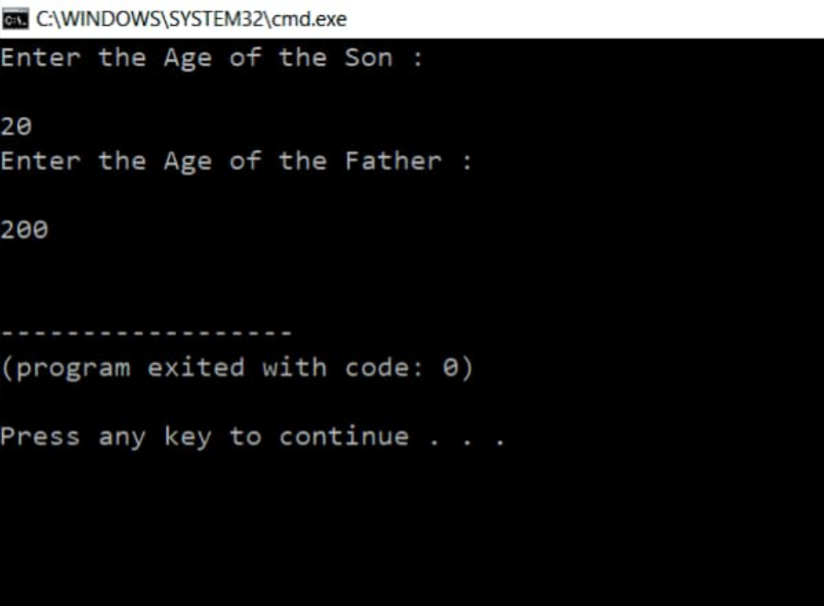

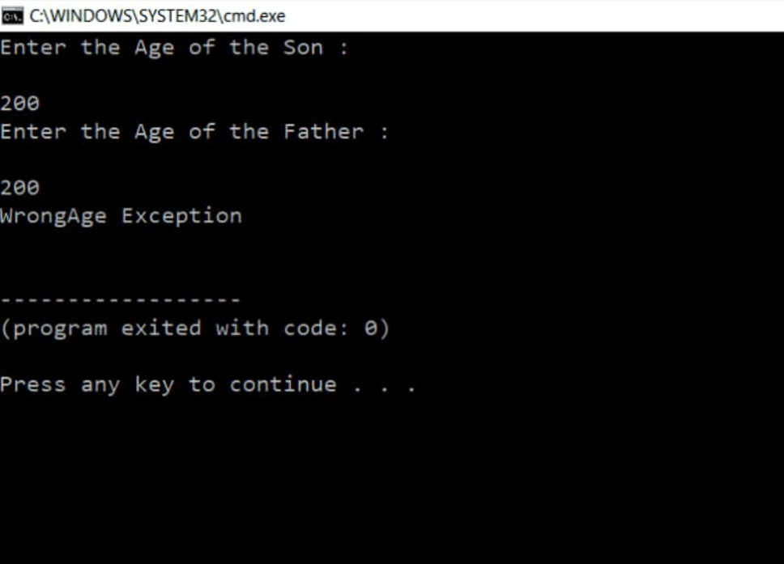

Lab-Program-9:

Write a program which creates two threads, one thread displaying “BMS College of

Engineering” once every ten seconds and another displaying “CSE” once every two seconds.

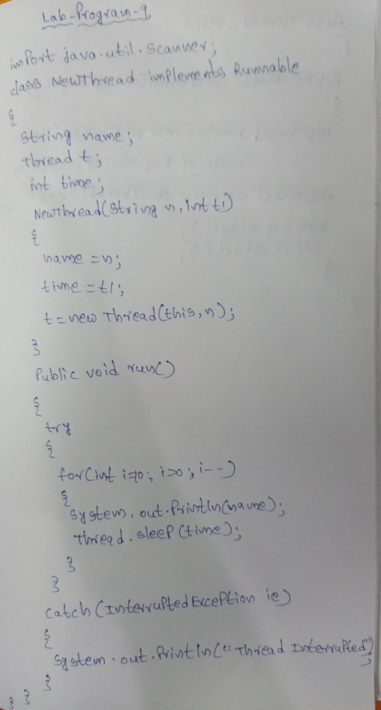

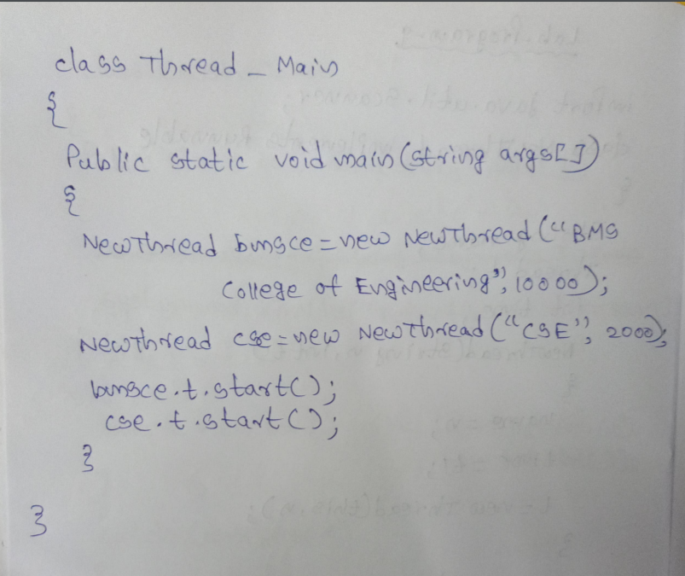

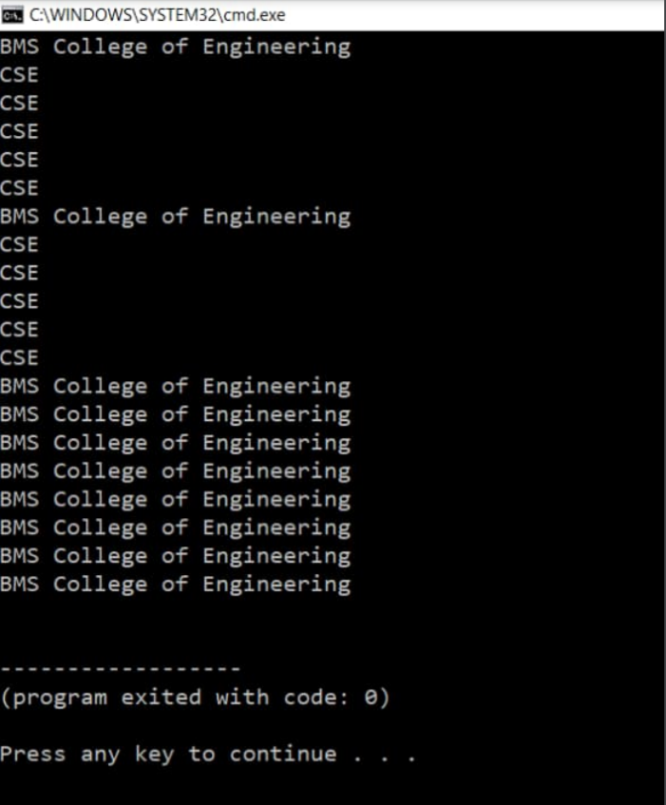

Lab-Program-10:

Write a program that creates a user interface to perform integer divisions. The user enters two

numbers in the text fields, Num1 and Num2. The division of Num1 and Num2 is displayed in the

Result field when the Divide button is clicked. If Num1 or Num2 were not an integer, the program

would throw a NumberFormatException. If Num2 were Zero, the program would throw an

Arithmetic Exception Display the exception in a message dialog box.

